SAHANA M – [**SAHANAM6@DELOITTE.COM**](mailto:SAHANAM6@DELOITTE.COM)

MILESTONE 1 sub 1

Table created in snowflake after querying in Atom

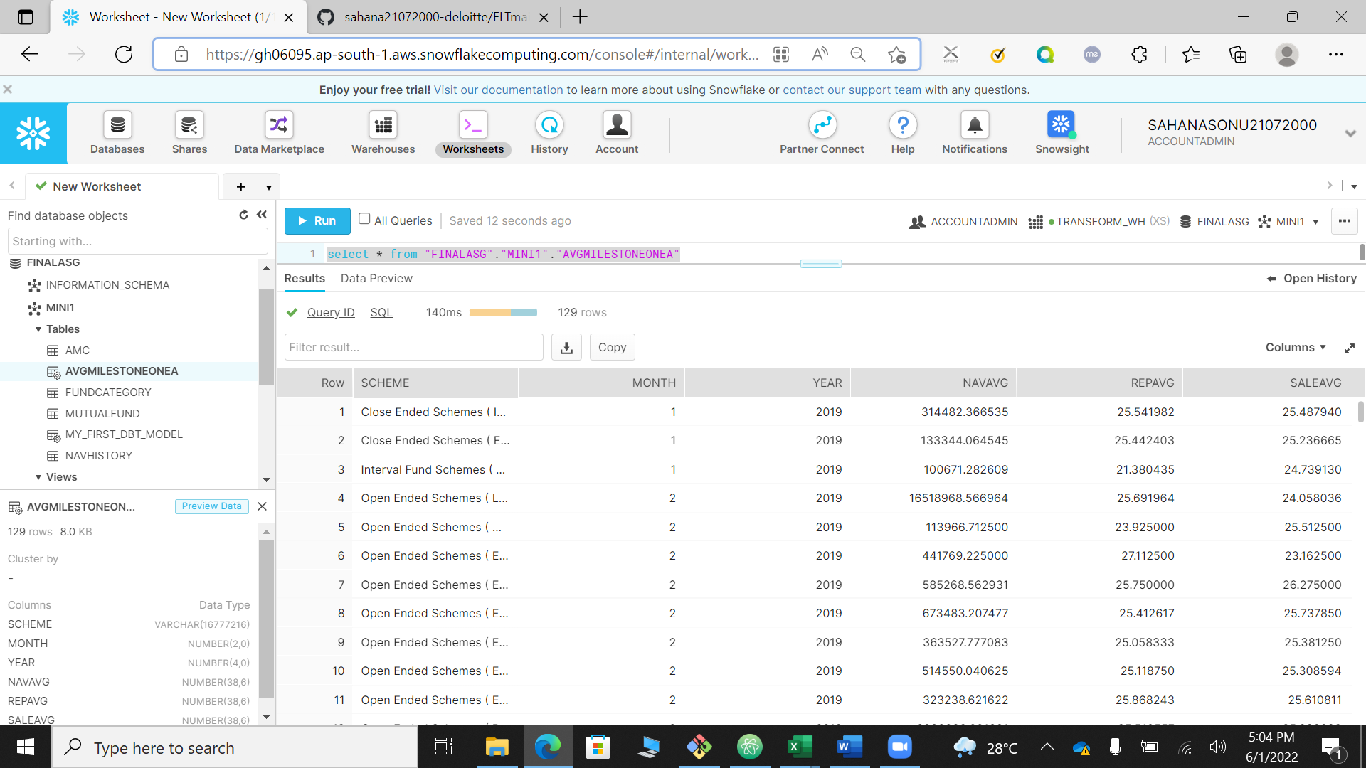

MILESTONE 1 sub 2

MILESTONE 2 sub 3

MILESTONE 2 sub 1

MILESTONE 2 sub 4

